Preparation of Manuscripts for the

2019 IEEE Nuclear Science Symposium
and Medical Imaging Conference
First A. Author, Second B. Author, Jr., and Third C. Author, Member, IEEE

Abstract–These instructions provide guidelines for preparing manuscripts for submission to the Conference Record (CR) of the 2019 IEEE Nuclear Science Symposium and Medical Imaging Conference. If you are using Microsoft Word to prepare your manuscript, you should use this document as a template. Define all symbols used in the abstract. Do not cite references in the abstract. Do not delete the blank line immediately above the abstract; it sets the footnote at the bottom of this column.

INTRODUCTION
T
his document is a template for Microsoft Word. It provides instructions for authors that will be presenting a paper at the 2019 IEEE Nuclear Science Symposium and Medical Imaging Conference (NSS-MIC), and should be used in preparing and submitting manuscripts to the Conference Record (CR). The Conference Record is a non-refereed publication that is made available to all conference attendees after the conference for download. A detailed description of the CR submission procedure is provided in section II below. The deadline for the submission of a manuscript to the CR is 13 December 2019.
Additionally, you may choose to submit a manuscript to the relevant IEEE journal: IEEE Transactions on Nuclear Science (TNS), or IEEE Transactions on Radiation and Plasma Medical Sciences (TRPMS) or IEEE Transactions on Medical Imaging (TMI) if it represents significant original contributions in the fields associated with the conference (i.e., progress reports and preliminary findings are not appropriate). These refereed publications are published throughout the year. For instructions on manuscript submissions to these journals, please visit IEEE's on-line peer review system Manuscript Central™ either http://mc.manuscriptcentral.com/tns-ieee or http://mc.manuscriptcentral.com/trpms or http://mc.manuscriptcentral.com/tmi-ieee and look for the Resources links underneath the Log In section. Please note that submission to these journals is a separate process from that of the Conference Record, and that the same material cannot be published in both the Conference Record and any IEEE journal. Further information about IEEE’s intellectual property rights is available at http://www.ieee.org/publications_standards/publications/rights/index.html and on the conference web site (https://www.nssmic.org/2019/publication).

Online Template
You can download this template, in both MS Word and PDF format, from the NSSMIC18 conference web site (https://www.nssmic.org/2019/publication) so that you can use it to prepare your manuscript. A LaTeX style and sample files are also available from the same web page. For authors using word processors other than LaTeX or Word, Table I gives the font sizes and formats that are used in this document. Use “Times New Roman” font or its equivalent on your system. The preferred paper size is US Letter (8.5” ×11”). The height of the text is 9.6” (244mm), and width of each column is 3.5” (89mm), with a 0.2” (5mm) separation between columns. If you must use A4 paper size, please set the top and bottom margins to be 27mm, and left and right margins to 14mm to maintain the same width and height of the text area.
When you open NSSMIC19.docx as a Word file, select “Page Layout” or “Print Layout” from the “View” menu in the menu bar, which allows you to see the footnotes. Then type over sections of NSSMIC19.docx or cut and paste from another document and then use markup styles. Highlight a section that you want to designate with a certain style, and then select the appropriate name on the style menu. The style will adjust your fonts and line spacing. Do not change the font sizes or line spacing to squeeze more text into a limited number of pages. Use italics for emphasis; do not underline.

Table I. Font sizes and format

Element Font Size Font Type Spacing
Title 24 pt Normal N/A
Authors 11 pt Normal 16 pt before, 1 pt after
Abstract 9 pt Bold N/A
Heading 1 10 pt Small Caps 12 pt before, 4 pt after
Heading 2 10 pt Italics 6 pt before, 3 pt after
Heading 3 10 pt Italics N/A
Text 10 pt Normal “Multiple” at 1.05
Footnote 8 pt Normal N/A
Table Title 8 pt Small Caps N/A
Figure 8 pt Normal N/A
References 8 pt Normal N/A

Procedure for Manuscript Submission
The manuscript submission is done online on the paper submission web site. See details below. All questions regarding CR submission should be directed to the Paper and Publication Co-Chairs, Andrew Goertzen (Andrew.Goertzen@umanitoba.ca) and Gian-Franco Dalla Betta (gianfranco.dallabetta@unitn.it).

Create IEEE Xplore-Compatible PDF File
All conference record manuscripts submitted to IEEE must be in Xplore-compatible PDF format. To assist authors in meeting this requirement, IEEE has established a web based service called PDF eXpress. This year you must use this web service, either to convert your word processor files into Xplore-compatible PDF files or to check an already-created PDF file. PDF eXpress converts the following file types to PDF: Rich Text Format (RTF), (La)TeX (DVI and all support files required), PageMaker, FrameMaker, Word Pro, QuarkXpress, Microsoft Word, and WordPerfect.
The PDF eXpress service will be available to the NSSMIC19 authors between September 1 and December 13, 2019. To use this service, go to http://www.pdf-express.org and enter 42101X as the Conference ID. If you are a first time user of this system, you need to set up an account.
Once you have logged in, follow the instructions to ‘Create New Title’. Then you can upload your word processor or PDF file to the web site to have it checked for IEEE Xplore compatibility. Shortly after your upload you will receive an email from IEEE PDF eXpress Site Services containing a compatibility report. If the file you submit to IEEE PDF eXpress does not pass PDF Check, the body of the email will contain detailed information about what needs to be changed. Please modify the file accordingly and then resubmit to IEEE PDF eXpress. Repeat this process of modification then resubmission to IEEE PDF eXpress until the subject line of the email from IEEE PDF eXpress Site Services says “IEEE PDF eXpress: File has passed PDF Check”. The new PDF which is attached to that message is the only file that the Conference Record submission site will accept. It is very important that you do not modify that PDF in any way or change its filename. Otherwise your file will be rejected by the CR submission site.
If you encounter problems in generating an IEEE PDF eXpress-compatible PDF, extensive help is available at https://www.pdf-express.org/pdfcheck.asp. In addition, answers to many common questions can be found by going to https://supportcenter.ieee.org/app/home and typing appropriate search terms into the ‘Find Answers’ blank, e.g. PDF create. Any questions about CR submission should be directed to the Paper and Publication Co-Chairs, Andrew Goertzen (Andrew.Goertzen@umanitoba.ca) and Gian-Franco Dalla Betta (gianfranco.dallabetta@unitn.it).
The key requirements for Xplore-compatible PDF files are:
- Do not protect your PDF file with any password;
- Embed and subset all fonts used in the document.
The most common problem in creating Xplore-compatible PDF files is not embedding all fonts.
Users of (La)TeX should use Type 1 postscript fonts when converting dvi file into postscript. If you are using older versions of dvips to generate the postscript file, you might need to include “-P pdf” in the command line to produce postscript file optimized for distilling to PDF.

Submit the Copyright Form and Manuscript
After you have obtained the Xplore-compatible PDF file, from the PDF eXpress service, log on to the site where you submitted your abstract (https://www.eventclass.org/contxt_ieee2019) using the username and password for your abstract submission. Go to the “My Submissions” link. For each of your accepted submissions the UPLOAD button at the bottom line is active. Please press it.
Before you will be able to upload your PDF you must fill out the IEEE electronic Copyright Form (eCF). Click on the button ‘Start IEEE electronic copyright form (eCF) process’. Follow the instructions and the step by step guided process. After you have finished the eCF process successfully, you will be automatically routed back to manuscript upload page. Each contribution requires its own eCF, which has to be completed only once. If you are not the person who is authorized to sign the eCF form you will be asked during the eCF process to identify the person who IS eligible. This person will be informed automatically by e-mail and invited to complete the eCF process. After the authorized person has successfully done so, the upload of the manuscript will be enabled.
Successfully passing the eCF process is mandatory before the upload link will become active. Further information about the IEEE Copyright Form is available at: http://www.ieee.org/publications_standards/publications/rights/copyrightmain.html.
Next please press the ‘upload of Conference Record’ button, select the file on your computer and start the upload. Your PDF file will be checked to ensure that it is an IEEE Xplore-compatible file which has been verified by the IEEE PDF eXpress webservice. Files that do not meet this requirement will be rejected.
Once the upload has succeeded please double-check the uploaded file to ensure that you have submitted the correct one.
The deadline for submissions to the Conference Record is December 13, 2019.

MATH
Use the Microsoft Equation Editor for all math objects in your paper. "Float over text" should not be selected.
A math object is any equation or fragment containing mathematical symbols (including Greek characters, superscripts and subscripts) that appears either in-line (in the flow of normal text) or as a display equation (in its own space between lines of text).
You should avoid using Word fonts or symbols for in-line single variables with superscripts or subscripts.

Units
Use either SI (MKS) or CGS as primary units. (SI units are strongly encouraged.) English units may be used as secondary units (in parentheses). An exception is when English units are used as identifiers in trade, such as "3.5 inch disk drive." Avoid combining SI and CGS units, such as mass in kilograms and volume in cubic centimeters. This often leads to confusion because equations may not balance dimensionally. If you must use mixed units, clearly state the units for each quantity in an equation.

Helpful Hints

Figures and Tables
Use the abbreviation "Fig." throughout the text of your manuscript, even at the beginning of a sentence, as well as in the figure captions. Do not abbreviate "Table." Tables are numbered with Roman numerals. Do not put borders around your figures.
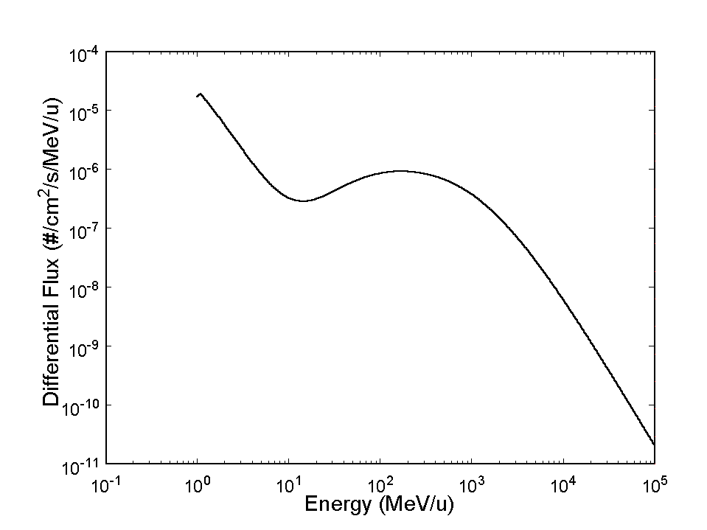
Fig. 1. Interplanetary galactic cosmic ray iron ion counts as a function of ion energy. Note that "Fig." is abbreviated. There is a period after the figure number, followed by two spaces. It is good practice to explain the significance of the figure in the caption. This figure was originally created in a graphics program, AXUM. The graph was copied as "Copy Graph Sheet Page" to the Windows Clipboard. In PowerPoint, a new file was opened and the contents of the Clipboard were pasted as a "Picture (Enhanced Metafile)". It was then saved as a TIFF formatted file named 1FIG.TIF. The image file was then inserted into this Word document as a "Picture".

Figure axis labels are often a source of confusion. Use words rather than symbols. As an example, write the quantity "Energy," or "Energy, E," not just "E." Put units in parentheses. Do not label axes only with units. As in Fig. 1, for example, write "Energy (MeV/u)" or "Energy ()," not just "MeV/u." Do not label axes with a ratio of quantities and units. For example, write "Temperature (K)," not "Temperature/K."
Multipliers can be especially confusing. Write "Dose (krd/s)" or "Dose (10³ rd/s)." Do not write "Dose(rd/s) 1000" because the reader would not know whether an axis label of 16 meant 16000 rd/s or 0.016 rd/s. Figure labels should be legible, approximately 8 to 10 point type.
To provide consistent reproducibility, please include axes and tick marks on all four sides of your graphs and avoid the use of grid lines (note that grid lines tend to clutter a graph if dark or reproduce poorly if light). Please also include an explanatory legend within your graphs when two or more curves or sets of data are included. Avoid explaining the different symbols and curves in the figure caption alone - using a legend results in a much more easily understood figure.

References
Number citations consecutively in square brackets [1]. The sentence punctuation follows the brackets [2]. Multiple references [2], [3] are each numbered with separate brackets [1]–[3]. When citing a section in a book, please give the relevant page numbers [2]. In sentences, refer simply to the reference number, as in [3]. Do not use “Ref. [3]” or “reference [3]” except at the beginning of a sentence: “Reference [3] shows ... .” Type the reference list at the end of the paper using the “References” style.
Please note that the references at the end of this document are in the preferred referencing style. Give all authors’ names; do not use “et al.” unless there are six authors or more. Use a space after authors' initials. Papers that have not been published should be cited as “unpublished” [4]. Papers that have been submitted for publication should be cited as “submitted for publication” [5]. Papers that have been accepted for publication, but not yet specified for an issue should be cited as “to be published” [6]. Please give affiliations and addresses for private communications [7].
Capitalize only the first word in a paper title, except for proper nouns and element symbols. For papers published in translation journals, please give the English citation first, followed by the original foreign-language citation [8].

Abbreviations and Acronyms
Define abbreviations and acronyms the first time they are used in the text, even after they have already been defined in the abstract. Abbreviations such as IEEE, SI, ac, and dc do not have to be defined. Abbreviations that incorporate periods should not have spaces: write "C.N.R.S.," not "C. N. R. S." Do not use abbreviations in the title unless they are unavoidable (for example, IEEE in the title of this article).

Equations
Number equations consecutively with equation numbers in parentheses flush with the right margin, as in (1). To make your equations more compact, you may use the solidus ( / ), the exp function, or appropriate exponents. Use parentheses to avoid ambiguities in denominators. Punctuate equations when they are part of a sentence, as in
(1)
Be sure that the symbols in your equation have been defined before the equation appears or immediately following. Refer to "(1)," not "Eq. (1)" or "equation (1)," except at the beginning of a sentence: "Equation (1) is ..."

Other Recommendations
Use one space after periods and colons. Hyphenate complex modifiers: "zero-field-cooled magnetization." Avoid dangling participles, such as, "Using (1), the potential was calculated." Write instead, "The potential was calculated by using (1)," or "Using (1), we calculated the potential."
Use a zero before decimal points: "0.25," not ".25." Use "cm³," not "cc." Indicate sample dimensions as "0.1 cm × 0.2 cm," not "0.1×0.2 cm²." Do not mix complete spellings and abbreviations of units: use "J/cm²" or "fluence per square centimeter," not "fluence/cm²." When expressing a range of values, write "7 to 9," not "7-9" or "7~9," except for references [1]-[3].
Use the correct format for scientific notation in text, tables, and figures. Computer notation of "E" for "10" is not permitted. For example, numbers expressed as 6.02E-3, instead of 6.0210, are not acceptable.
A parenthetical statement at the end of a sentence is punctuated outside of the closing parenthesis (like this). (A parenthetical sentence is punctuated within the parentheses.) In American English, periods and commas are within quotation marks, like "this period." Other punctuation is "outside"!
If you wish, you may write in the first person singular or plural and use the active voice ("I observed that ..." or "We observed that ..." rather than "It was observed that ..."). If your native language is not English, please get a native English-speaking colleague to proofread your paper.

Some Common Mistakes

Common Formatting Mistakes
- Manuscript title and all headings must be in Title Case. (In title case, each word is capitalized except for the connecting words, such as articles and prepositions. You may have to manually correct Word's tendency to put every word of the title into Title Case.)
- Font size and aspect of figures captions and table captions should be as indicated in the template. You can use the styles “FigureCaption” and “TableTitle” to format these elements correctly.
- Author affiliations go in the unnumbered footnote on the first page.
- No headers, footers, or page numbers.
- No extra blank lines need to be inserted – the styles are there to give the right amount of space around the elements.

Some Other Common Mistakes
The word "data" is plural, not singular. The subscript for the permeability of vacuum is zero, not a lowercase letter "o." Use the word "micrometer" instead of "micron." A graph within a graph is an "inset," not an "insert." The word "alternatively" is preferred to the word "alternately" (unless you really mean something that alternates). Do not use the word "essentially" to mean "approximately" or "effectively." Be aware of the different meanings of the homophones "affect" and "effect," "complement" and "compliment," "discreet" and "discrete," "principal" and "principle." Do not confuse "imply" and "infer."
Prefixes such as “non,” “sub,” “micro,” “multi,” and “ultra” are not independent words; they should be joined to the words they modify, usually without a hyphen. There is no period after the “et” in the Latin abbreviation “et al.” (it is also italicized). The abbreviation “i.e.,” means “that is,” and the abbreviation “e.g.,” means “for example” (these abbreviations are not italicized).
An excellent style manual and source of information for science writers is [9].
Appendix
Appendices, if needed, appear before the acknowledgment.

Acknowledgment
The preferred spelling of the word "acknowledgment" in American English is without an "e" after the "g." Use the singular heading even if you have many acknowledgments. Avoid the expression, "One of us (S.B.A.) thanks ..." Instead, write "S.B.A. thanks ..." Put sponsor acknowledgments in the unnumbered footnote on the first page.
We thank Tony Seibert for writing the original version of this document and Bo Yu for the following versions.
We also thank Bo Yu for all the help and support he constantly gives us.

References
- F. W. Sexton, D. M. Fleetwood, M. R. Shaneyfelt, P. E. Dodd, and G. L. Hash, "Single event gate rupture on thin gate oxides," IEEE Trans. Nucl. Sci., vol. 44, no. 6, pp. 2345-2352, Dec. 1997.
- J. Clerk Maxwell, A Treatise on Electricity and Magnetism, 3rd ed., vol. 2. Oxford: Clarendon, 1892, pp. 68-73.
- I. S. Jacobs and C. P. Bean, "Fine particles, thin films and exchange anisotropy," in Magnetism, vol. III, G. T. Rado and H. Suhl, Eds. New York: Academic, 1963, pp. 271-350.
- K. Elissa, "Title of paper," unpublished.
- R. Nicole, "Title of paper with only first word capitalized," J. Name Stand. Abbrev., submitted for publication.
- J. Wang, “Fundamentals of erbium-doped fiber amplifiers arrays (Periodical style—Submitted for publication),” IEEE J. Quantum Electron., submitted for publication.
- C. J. Kaufman, Rocky Mountain Research Laboratories, Boulder, CO, personal communication, 1992.
- Y. Yorozu, M. Hirano, K. Oka, and Y. Tagawa, "Electron spectroscopy studies on magneto-optical media and plastic substrate interface," IEEE Transl. J. Magn. Jpn., vol. 2, pp. 740-741, August 1987 [Dig. 9th Annual Conf. Magn. Jpn., p. 301, 1982].
- M. Young, The Technical Writer's Handbook. Mill Valley, CA: University Science, 1989.

Manuscript received November 1, 2019. (Write the date on which you submitted your paper for review.) This work was supported in part by the U.S. Department of Commerce under Grant No. BS123456 (sponsor acknowledgment goes here). Paper titles should be written in uppercase and lowercase letters, not all uppercase. Avoid writing long formulas with subscripts in the title; short formulas that identify the elements are acceptable (e.g., "Nd-Fe-B"). Do not write "(Invited)" in the title. Do not begin a title with the word "On ... ." Full names of authors are preferred in the author field, but are not required. Put a space between authors' initials. Do not use all uppercase for authors' surnames. F. A. Author is with the National Institute of Standards and Technology, Boulder, CO 80303 USA (telephone: 303-497-3650, e-mail: author @boulder.nist.gov). S. B. Author, Jr., was with Rice University, Houston, TX 77005 USA. He is now with the Department of Physics, Colorado State University, Ft. Collins, CO 80523 USA (telephone: 970-491-6206, e-mail: author@lamar. colostate.edu). T. C. Author is with the Electrical Engineering Department, University of Colorado, Boulder, CO 80309 USA, on leave from the National Research Institute for Metals, Tsukuba, Japan (e-mail: author@nrim.go.jp).

